**Table of Contents**

1. **Purpose and Scope**
2. **Responsibility**
3. **Precautions**
4. **Quality Assurance**
5. **External Features of the Intox DMT**
6. **Overview of Intox DMT Operational Principles**
7. **Process for Obtaining a DUI Evidentiary Subject Breath Test**
8. **Process for Obtaining a Check-In Confirmation Test**
9. **Time Restrictions on Data Entry and Processing**
10. **Common Error Messages and Responses**
11. **Appendices**
12. **Purpose and Scope**
    1. The purpose of this manual is to describe the process used by law enforcement officers in the operation of the Intox DMT evidential breath alcohol testing instruments. DMT operators are trained by VFL staff and are certified to obtain evidential breath tests using the Intox DMT.
    2. This manual provides DMT operators with a brief overview of the underlying scientific principles and functioning of the DMT, operating protocols, and common error conditions and appropriate responses. The information provided in this manual is not designed to make the DMT operator an expert on the DMT, but will familiarize them with the instrument in order to properly collect evidential breath tests and respond to common error conditions. An in-depth understanding of the science behind the DMT, instrument mechanics, optics, and electronics is not required to be certified as a DMT operator.
13. **Responsibility**
    1. It is the responsibility of the DMT operator performing these tasks to follow the procedure as written and to note any omissions, errors, or unclear instructions in the procedure and bring them to the attention of a DMT Supervisor or the VFL Toxicology Section.
    2. This manual will be reviewed periodically by Toxicology Section staff. Revisions of the manual will be made when a need is identified.
    3. All individuals performing these procedures must be trained by qualified VFL staff and demonstrate competency in the use of these procedures before being certified as a DMT operator. A DMT operator demonstrates competency by successfully completing a written test along with a hands-on practical exercise.
14. **Precautions** 
    1. Appropriate caution must be taken to avoid electrical shock when working with or using any electrically charged equipment.
15. **Quality Assurance**
    1. It is expected that DMT operators will report any unacceptable or anomalous behavior regarding the operation or use of the DMT immediately to a DMT Supervisor or the VFL Toxicology Section. It is further expected that appropriate actions will follow as soon as possible and be properly documented.
    2. DMT operators should report any error conditions to a DMT Supervisor at their agency. When reporting error conditions, be as specific as possible.
16. **External Features of the Intox DMT**
    1. Breath tube
    2. Keyboard
    3. LCD touch screen
    4. Power ON/OFF Switch
    5. Serial number
    6. Stylus
    7. Simulator

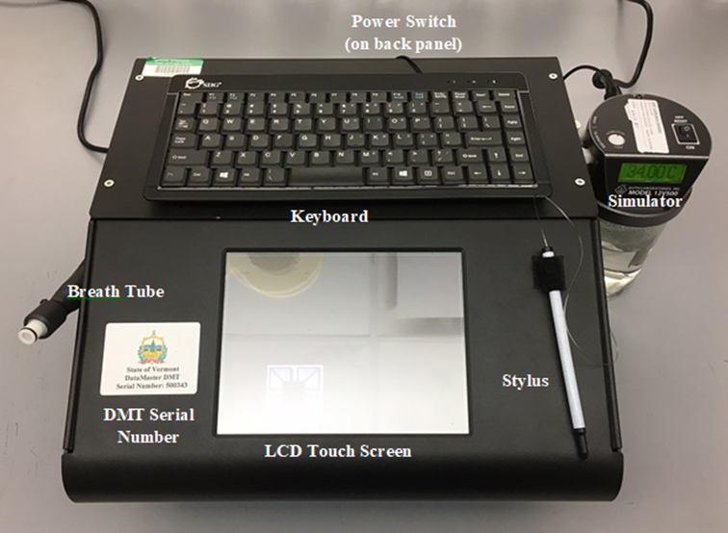

**Figure 1. External features of the DMT**

1. **Overview of Intox DMT Operational Principles**
   1. The DMT undergoes a number of quality control checks to ensure an accurate and reliable analysis of the breath sample introduced to it. Prior to a breath sample being collected, the DMT checks its components for function including heated zones and detector response, purges air through the system, adjusts baseline readings to the ambient air and verifies there is no alcohol present, analyzes a simulated breath containing alcohol vapor to verify the DMT meets performance criteria, and performs another blank test ensuring there is no alcohol remaining in the sample chamber. Once all of these quality control checks are successfully completed, a breath sample may be collected.
   2. The DMT measures the quality of the breath sample being introduced using sample acceptance criteria. Figure 2 below is a graphic example of how a breath sample is monitored to ensure that the sample meets these criteria. As a sample is introduced into the instrument, the flow rate is continuously monitored. When the minimum flow rate is reached, the flow must remain at or above that rate until at least 1.5 liters of breath has been provided. Simultaneously, the apparent alcohol concentration in the sample is measured four times per second. A valid breath sample is expected to show a rise and eventual plateau in the alcohol curve as breath continues to be delivered. The sample continues to be collected until the breath flow rate falls back below the minimum flow rate. Once the breath sample is collected, it is analyzed at three (3) different wavelengths to ensure there are no other volatiles present in the sample that would interfere with the analysis of ethanol. These criteria must be met for the instrument to accept a sample.

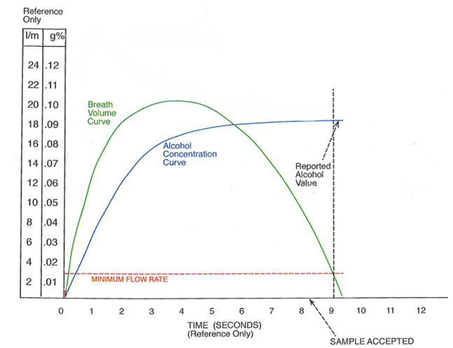

**Figure 2. Example breath acceptance criteria. Note: line colors are not representative of actual DMT screen.**

1. **Process for Obtaining a DUI Evidentiary Subject Breath Test**
   1. If the screen saver is active, touch the screen to clear it.
   2. Confirm that the DMT displays “Ready” and flashes “Push Run”. If the instrument is turned off, displays “Out of Service”, or is otherwise not ready for use, go to a different DMT site.
   3. Push “Run” to begin the testing sequence.
   4. From the “Type of Test” window select “DUI.”
   5. Enter information in the boxes as requested. See Figure 3 for an example of the data entry screen.
      1. Use stylus or [tab] on the keyboard to move between fields.
      2. Bold lettering indicates a required field.
      3. The age of the subject and county of the incident will be auto-populated based on the date of birth and town entries, respectively. The “Guardian” field will be enabled if the subject is younger than 18.
      4. Some fields are populated using a drop down box. Scroll and select an option with the stylus or begin typing into these fields and a drop down list will appear based on text input. Select the appropriate response using the stylus.

Note: The “Agency” field is sorted by town or county first. For example, the Sheriff’s Office and the Vermont State Police Barracks located in Rutland are listed as Rutland County SO and Rutland VSP, respectively.

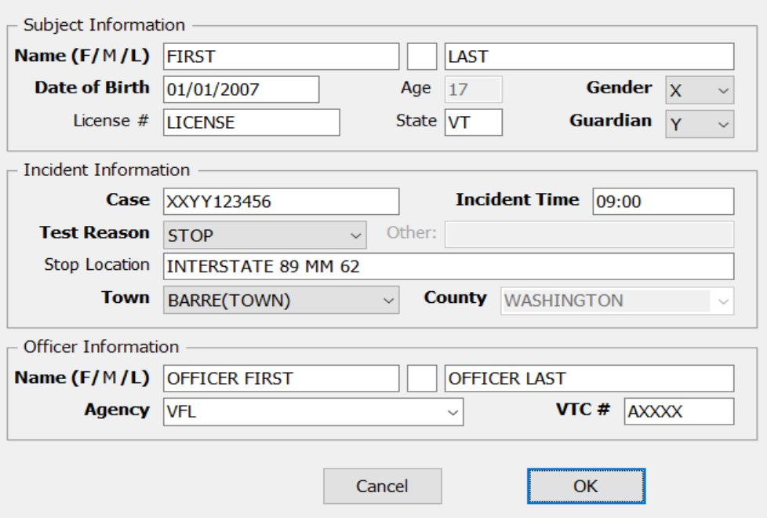

**Figure 3. Example of DUI data entry screen.**

* 1. Once all of the information is entered select “OK” on the screen or press [Enter].
  2. A box will pop up prompting “Would you like to review your data? Yes or No”. Select “Yes”.
  3. Review the information entered for accuracy.
  4. Once the data has been reviewed for accuracy, select “OK” or press [Enter]. The box requesting data review will pop up again. Select “No” to proceed to the test sequence.

**Observation Period**

* 1. Upon completion of the data entry, a pop up box will appear prompting, “Ensure subject’s mouth is free from foreign objects”.
  2. Visually observe the subject for any evidence of food, gum, tobacco, or any other foreign matter in the mouth. Ask the subject if they have anything in their mouth. Anything in the mouth must be removed prior to starting the next step.

Note: Tongue piercings and dentures may remain in the mouth.

* 1. Once this check is complete, press “OK”.
  2. The DMT is programmed with a mandatory 15 minute timer for the observation period. The 15 minute timer must be satisfied before a subject breath sample can be collected.
  3. The DMT will prompt, “Start Timer?”. Select “OK” to start the timer.
  4. Observe the subject for 15 uninterrupted minutes. **The subject must be within visual and audio proximity for the entire 15 minutes preceding the test.** If at any time the subject burps, belches, or vomits, the observation period must be restarted. If at any time the subject puts something into or removes something from their mouth, the item must be removed and the observation period restarted. If the officer needs to leave the visual or audio proximity of the individual for any length of time, the observation period must be restarted.
  5. If at any point the observation period needs to be restarted, select “Restart”. A pop up box will appear allowing the user/officer to input a reason for restarting. Enter the reason for restarting the observation period e.g. subject burped, subject used restroom, etc.
  6. The timer may also be started prior to data entry. To do this, press the “Start Timer” radio button located on the DMT home screen. After checking the subject’s mouth and pressing “OK”, a small pop-up box will appear with a 15 minute timer counting down.
  7. Once the 15 minute timer has been satisfied, the instrument will automatically begin its quality control checks. If any of the checks do not meet acceptance criteria, the test will be aborted.
  8. Upon the successful completion of the quality control checks, the DMT will prompt “Will subject take test? Yes or No”. If yes, proceed to step 7.28.

**Refusal or Incapable**

* 1. If the subject will not provide a breath sample, select “No”.
  2. The instrument will then prompt “Refusal or Incapable?”
  3. If the subject physically cannot provide an adequate sample, select “Incapable”. If the subject is incapable of providing a sample, you may request a blood sample.
  4. If the subject refuses to provide a sample, select “Refusal”.
  5. In both instances a pop up will prompt the user/officer to input a reason.
  6. Enter the reason why the subject did not provide a sample.
  7. The evidence report will indicate whether it was a refusal or incapable and include the entered reason.
  8. Proceed to step 7.46.

**Obtaining a DUI Subject Test**

* 1. If the subject consents to provide a breath test select “Yes”.
  2. When “Yes” is selected, the display will flash “PLEASE BLOW” and an intermittent tone will be heard.
  3. Insert a new mouthpiece into the breath tube.
  4. Instruct the subject to provide a steady, continuous breath sample.
  5. The officer should hold the breath tube during delivery of the breath sample.
  6. When the subject meets the minimum flow rate criteria the words “PLEASE BLOW” will stop flashing and remain steady on the screen. A constant tone will be heard.
  7. An individual should be allowed to deliver a sample for as long as they are able. The sample acceptance criteria are programmed into the instrument to determine if an adequate sample has been obtained.
  8. After the breath sample is accepted, immediately remove the mouthpiece and discard it.
  9. The DMT will go through some additional checks and then display the subject test result on the screen.
  10. **Inform the subject of the BrAC result then ask if they want to provide a second test.**
  11. The instrument will then prompt “Will subject provide another sample? Yes or No”.
  12. If the subject declines the second test, the officer should select “No” and proceed to step 7.46. The evidence report will indicate the result of the evidentiary test and will display “2nd test not requested”.

**Obtaining a Second DUI Subject Test**

* 1. If the subject requests a second test, the officer should select “Yes”. The instrument will again perform the quality control checks.
  2. Following successful completion of the quality control checks, the instrument will again display “Will subject provide another sample? Yes or No”.
  3. If the subject has decided not to take a second test, select “No” and an evidence report will be printed. The evidence report will indicate the result of the first evidentiary test and will display “2nd test not requested”.
  4. If the subject consents to a second test, the officer should select “Yes”. The instrument will display “PLEASE BLOW” and an intermittent tone will be heard.
  5. Insert a new mouthpiece into the breath tube and instruct the subject to provide a breath sample as before.
  6. Once the breath sample is accepted immediately remove the mouthpiece and discard it.

**Place of Last Drink (POLD)**

* 1. Upon completion of the testing sequence, the DMT will prompt “During the course of your investigation, did you determine where the subject took their last drink? Yes or No”. If, during the investigation, it was determined where the subject ingested their last drink, select “Yes”. If it is unknown where the subject had their last drink, select “No”.
  2. If “Yes” was selected, the DMT will then prompt “Was the subject’s last drink at a licensed liquor establishment or permitted event? Yes or No”. If it was determined that the subject’s place of last drink took place at one of these locations, select “Yes”.
  3. If it was determined that the subject’s place of last drink did not occur at one of these locations, select “No”.
  4. Note: This question is for the processing or investigating officer. Results will not be printed on the ticket.

**What to do with the ticket?**

* 1. The evidence report is printed in triplicate at completion of the test sequence. One copy should be:
     1. Retained with the rest of the case paperwork for submission to the State’s Attorney.
     2. Retained by the arresting officer.
     3. Given to the subject.
  2. If an error is obtained at any point during the testing sequence, reference the DMT Quick Troubleshooting Guide located near the DMT instrument. If the issue is not resolved and another DMT is reasonably available, take the subject to another agency.
  3. If you received an error while attempting to collect a second test and have to go to another agency, get two new tests at the second agency.

1. **Process for Obtaining a Check-In Confirmation Test**
   1. If the screen saver is active, touch the screen to clear it.
   2. Confirm that the DMT displays “Ready” and flashes “Push Run”. If the instrument is turned off, displays “Out of Service”, or is otherwise not ready for use, go to a different DMT site.
   3. Push “Run” to begin the testing sequence.
   4. From the “Type of Test” window select “Check In.”
   5. Visually observe the subject for any evidence of food, gum, tobacco, or any other foreign matter in the mouth. Ask the subject if they have anything in their mouth. Anything in the mouth must be removed prior to starting the next step.

Note: Tongue piercings and dentures may remain in the mouth.

* 1. Enter information in the boxes as requested. See Figure 4 for an example of the data entry screen.
     1. Use stylus or [tab] on the keyboard to move between fields.
     2. Bold lettering indicates a required field.
     3. The age of the subject will be auto-populated based on the date of birth. The “Guardian” field will be enabled if the subject is under 18.
     4. The agency field is populated using a drop down box. Scroll and select an option with the stylus or begin typing into this field and a drop down list will appear based on text input. Select the appropriate response using the stylus.

Note: The “Agency” field is sorted by town or county first. For example, the Sheriff’s Office and the Vermont State Police Barracks located in Rutland are listed as Rutland County SO and Rutland VSP, respectively.

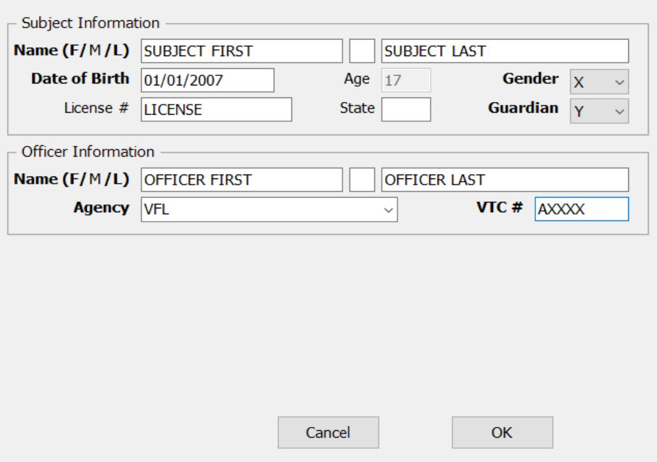

**Figure 4. Example of Check-In data entry screen.**

* 1. Once all of the information is entered select “OK” on the screen or press [Enter].
  2. A box will pop up prompting “Would you like to review your data? Yes or No”. Select “Yes”.
  3. Review the information entered for accuracy.
  4. Once the data has been reviewed for accuracy, select “OK” or press [Enter]. The box requesting data review will pop up again. Select “No” to proceed to the test sequence.
  5. The instrument will automatically begin its quality control checks. If any of the checks do not meet acceptance criteria, the test will be aborted.
  6. Upon the successful completion of the quality control checks, the display will flash “PLEASE BLOW” and an intermittent tone will be heard.
  7. Insert a new mouthpiece into the breath tube.
  8. Instruct the subject to provide a steady, continuous breath sample.
  9. The officer should hold the breath tube during delivery of the breath sample.
  10. When the subject meets the minimum flow rate criteria the words “PLEASE BLOW” will stop flashing and remain steady on the screen. A constant tone will be heard.
  11. An individual should be allowed to deliver a sample for as long as they are able. The sample acceptance criteria are programmed into the instrument to determine if an adequate sample has been obtained.
  12. After the breath sample is accepted, immediately remove the mouthpiece and discard it.
  13. The evidence report is printed in triplicate at completion of the test sequence. One copy should be:
      1. Retained with the rest of the case paperwork for submission to the State’s Attorney or Probation and Parole Officer.
      2. Retained by the officer administering the test.
      3. Given to the subject.
  14. If an error is obtained at any point during the testing sequence, reference the DMT Quick Troubleshooting Guide located near your DMT. If the issue is not resolved and another DMT is reasonably available, take the subject to another agency.

1. **Time Restrictions on Data Entry and Processing**
   1. Once the 15 minute observation timer is satisfied, the DMT will allow an additional ten (10) minutes to press the “Run” button and begin data entry. If the “Run” button is not pressed in this timeframe, the 15 minute observation timer will need to be restarted.
   2. When prompted to enter data, five (5) minutes is allotted. If data entry is not finished within the five (5) minutes the instrument will return to “Ready, Push Run”.
   3. When prompted to make a decision such as “Will Subject Take Test? Yes or No” or “Use Previous Data” one (1) minute is allotted.
   4. When prompting “PLEASE BLOW” the subject will have two (2) minutes to provide an adequate breath sample. If at the end of this time an adequate breath sample has not been provided the instrument will prompt “Will Subject Take Test? Yes or No.” After three (3) failures to obtain an adequate breath sample the instrument will rerun its quality control checks. It will then allow the subject up to three (3) more two (2) minute opportunities to provide an adequate sample. All completed and/or attempted breath tests will be documented on the evidence report.
2. **Common Error Messages and Responses**
   1. If any of the following error messages or conditions occurs, follow the procedures as described below. The following list reflects the most common errors, but is not an exhaustive list of all errors that may be encountered. The recommended responses to the error conditions listed are intended as guidance and are not mandatory actions.
   2. **For common error conditions and appropriate responses, reference the DMT Quick Troubleshooting Guide located near your DMT.**
   3. Some error messages may require a DMT Supervisor or VFL staff to inspect and/or service an instrument.
   4. **When receiving an error message it is permissible to retry the test**. If the second attempt results in a passing test, the subject results are acceptable. If the error reoccurs, it is recommended that the subject be taken to another agency, if another agency is reasonably available.
   5. If the error occurred while attempting to collect a second sample and you take the subject to a new agency, get two new tests at the second agency.
   6. DMT Supervisors should be made aware of any errors, even if the issue is resolved. Any and all reports generated during a testing sequence, including those displaying errors, should be retained with the case file.
   7. If an error condition cannot be remedied, post, “OUT OF SERVICE” on the DMT and leave a detailed message for the DMT Supervisor.
   8. **Blank Error or Ambient Fail:** The instrument is detecting apparent alcohol in the air.
      1. Move the subject away from the DMT and draw fresh air into the room by opening a door or window or turning on a fan.
      2. Remove the mouthpiece from the breath tube, if attached.
      3. Remove possible contamination sources from the processing area (e.g. hand sanitizer, cleaning reagents, alcohol prep pads, etc.).
   9. **BUSY – Please Wait:** The DMT froze while attempting to upload records to the intranet.
      1. Allow at least one minute for this message to go away. Do not push any buttons or attempt to run tests on the DMT while this message is displayed.
      2. If the message persists for longer than one (1) minute, power off the DMT and wait approximately 30 seconds then power on the DMT.
      3. Wait for the DMT to warm back up (approximately five (5) minutes) without pressing any additional buttons or initiating a test.
      4. Verify connection is restored by observing a  symbol in the lower right hand corner of screen.
   10. **Filter Wheel Error:** One of the DMT mechanical components did not align properly
       1. Try the test again.
       2. If the error reoccurs, go to another DMT site.
   11. **Incomplete:** The subject did not provide an adequate sample in the allotted time.
       1. Instruct the subject in the proper technique (deep breath, create tight seal with their lips, and continue to blow a long, continuous breath).
       2. Allow subject to try the test again. There are three 2-minute windows to provide a sample followed by quality control checks and then three additional 2-minute windows.
       3. INCAPABLE - Subject physically *cannot* provide an adequate sample. You may proceed as a DUI – Blood case and request a blood sample.
       4. REFUSAL - Subject *will not* provide an adequate sample. Based on *your* experience, you may deem this a refusal and proceed as such.
   12. **Interference (subject sample):** This message indicates there may be a chemical present in the sample other than ethanol.
       1. Allow the subject to provide a second sample. It is NOT necessary to restart the fifteen (15) minute observation period.
       2. If the second sample also reports INTERFERENCE, you may proceed as a DUI – Blood case and request a blood sample.
   13. **Invalid:** Subject breath profile did not meet the sample acceptance criteria.
       1. Ensure there are no possible contamination sources in the processing area (e.g. hand sanitizer, alcohol based cleaning reagents, alcohol prep pads, etc.).
       2. Ensure the mouth is free from foreign objects.
       3. Restart the 15 minute observation period.
       4. Instruct the subject again in the proper technique for providing a sample (deep breath, create a tight seal with their lips, and continue to blow a steady, continuous breath).

Note: Huffing and puffing may cause an invalid sample.

* + 1. Allow the subject to provide another sample.
  1. **Printer Error:** The instrument is unable to communicate with the printer.
     1. Follow these steps in this **EXACT ORDER.**
     2. Ensure the printer is plugged in to the wall and the cord connections between the DMT and printer are secure.
     3. Verify the printer is in proper working order (i.e. paper and ink supply are good and there are no error lights present).
     4. Power off the DMT using the switch on the back and wait approximately 30 seconds. Power on the DMT.
     5. Once the DMT is back online, press copy to verify printer function. This will print a copy of the most recent DMT test ticket.
     6. If you are unable to get the printer working, contact the lab at DPS.DMT@vermont.gov to request a copy of the DMT ticket.
  2. **Pump Error:** Air flow through the DMT is restricted.
     1. Most commonly occurs when a mouth piece is put on too early or left on after a breath test.
     2. Verify there is not a mouthpiece in the breath tube and visually check the end of the breath tube to ensure there are no obstructions.
  3. **RF Detected:** Radiofrequency was detected during the testing sequence.
     1. Ensure any radio transmitters in and around the processing area are turned off and try test again.
  4. **Simulator Out of Range:** The simulator vapor concentration is not within 5% of the target.
     1. Move the subject away from the DMT and try the test again.
     2. If the simulator vapor is still out of range, move on to another agency.
  5. **Static Analysis Error:** BrAC result did not meet sample acceptance criteria.
     1. Instruct the subject again in the proper technique for providing a sample (deep breath, create a tight seal with their lips, and continue to blow a steady, continuous breath for as long as they can).
     2. Allow the subject to try the test again.

1. **Appendices**
   1. **Appendix A: Example DMT Tickets**
   2. **Appendix B: DMT Quick Troubleshooting Guide**

**Appendix A**

DUI acceptable two breath test sequence

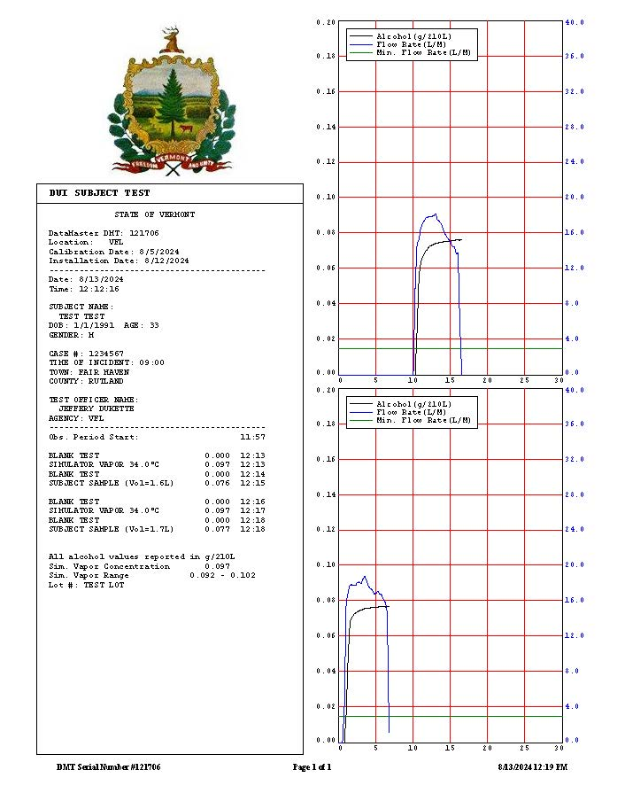

DUI invalid breath test

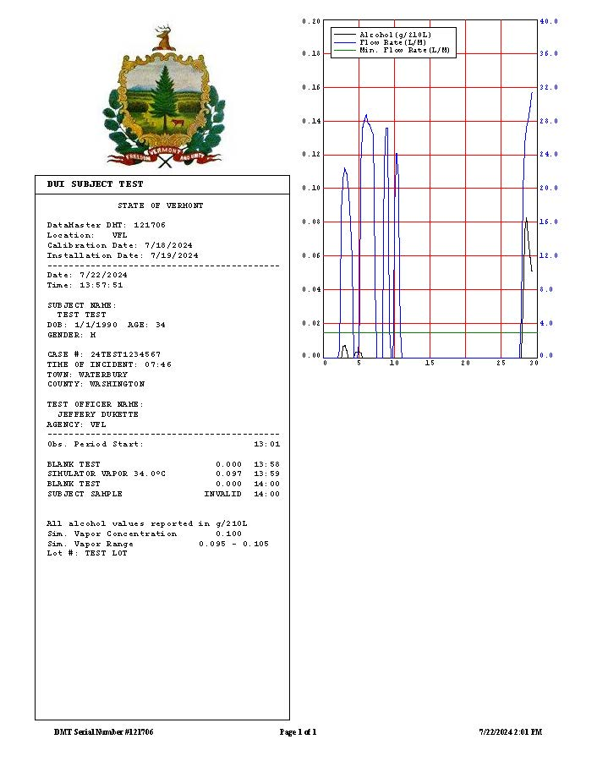

DUI incomplete subject breath test (6 attempts)

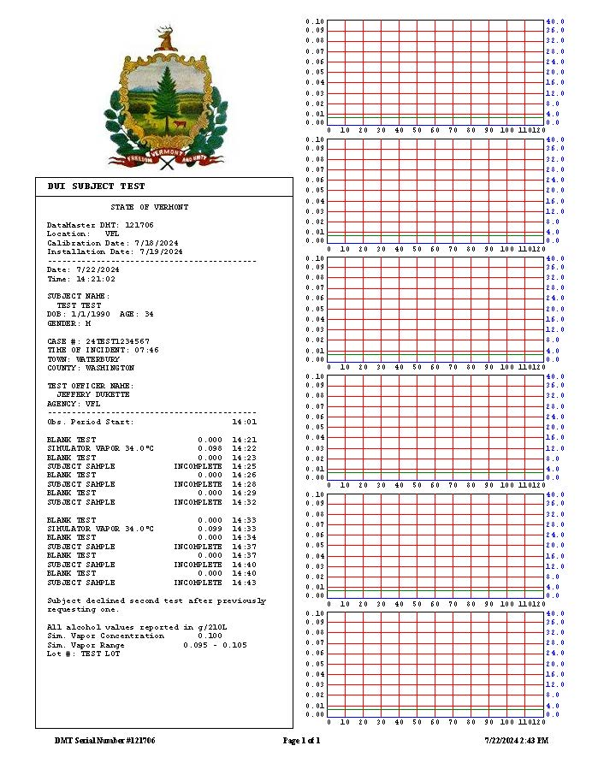

DUI interference on subject breath

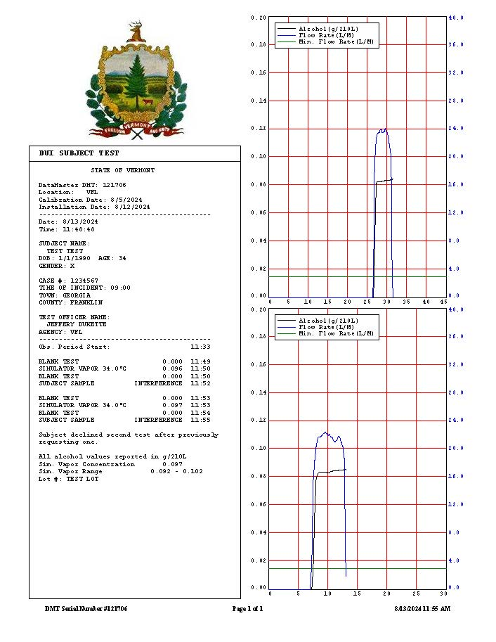

Check-in confirmation test

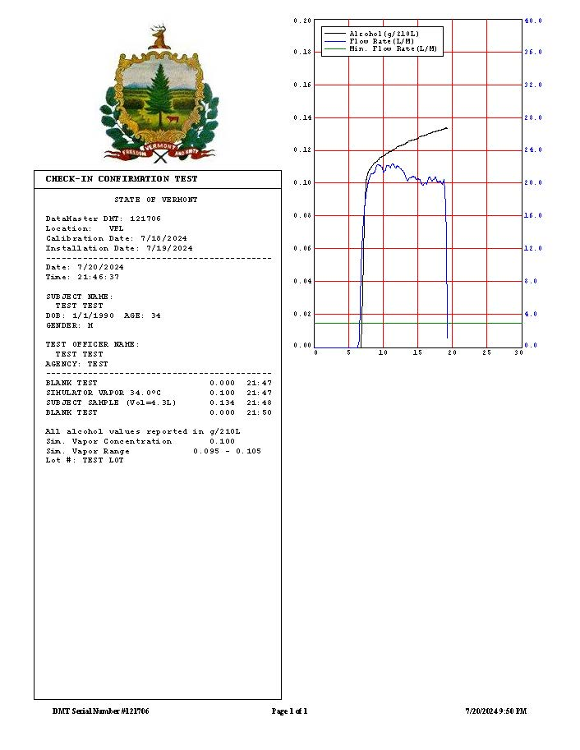

**Appendix B**



|  |  |  |  |
| --- | --- | --- | --- |
| DOCUMENT HISTORY | | | |
| **DATE** | VERSION | APPROVED BY | ACTIVITY OR REVISION |
| 08/26/2015 | 1 | Lab Director | Updated to new format; minor changes made throughout document |
| 07/13/2020 | 2 | Lab Director | Updated to new format (renamed from ALC_D200_2 to TOX_D200_2), added sections 1-4, clarified DMT operational principles, updated breath collection protocols to align with new DMT software, updated example DMT tickets, expanded common error messages and responses including troubleshooting guide, formatting changes throughout document |
| 09/23/2024 | 3 | Lab Director | Removed reference to the quartz disc; change to the POLD question; added static analysis error; updated screen shots; minor formatting changes throughout |
|  |  |  |  |
|  |  |  |  |
|  |  |  |  |
|  |  |  |  |
|  |  |  |  |
|  |  |  |  |
|  |  |  |  |
|  |  |  |  |
|  |  |  |  |
|  |  |  |  |
|  |  |  |  |
|  |  |  |  |